目 录
What is [E-Audit]?
For Administrator

Audit Template

Audit plan

Audit Record

Issue List

Report

Settings

For Users

Audit Plan

Audit Record

Issue List

Expired Plans

Mobile-based Audit

Anroid Application

Audit Record

Expired Plans

Issue List

Audit Plan

Android Audit

Deployment Options

What is [E-Audit]?

Making Audits Easier

What is [E-Audit]?
EasyAudit is an audit tool.

[E-Audit] APP
No download required, simply scan with WeChat to use it.

EasyAudit’s APP uses WeChat mini-programs, following the principle of “finish and go,” suitable for low-frequency usage scenarios.

What features does [E-Audit] have?
- Mobile APP
- Audit Form Management
- Cloud Management
- User Management
- Audit Plan
- Results Statistics

Multi-language Support
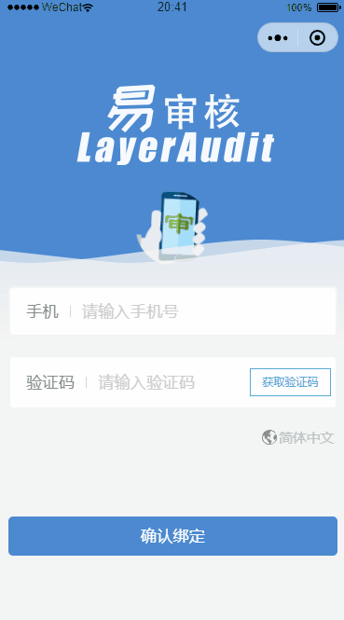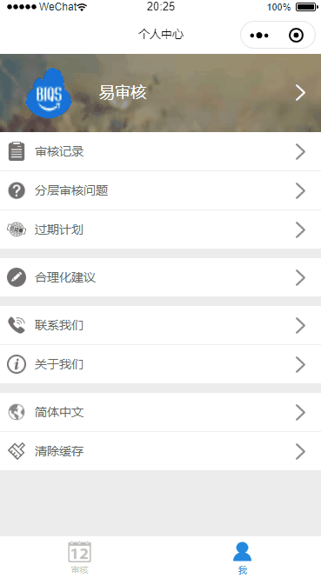

WeChat Notifications
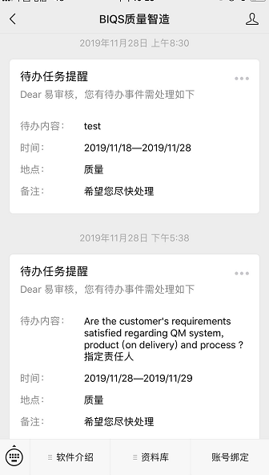

Feedback
If you encounter any problems during use, please feel free to give us feedback. You can contact us via:
- Email (service#biqs.cn, replace # with @)

For Administrator

In this chapter, we will learn how to manage Layered Process Audits
Audit Form Template
Audit Plan
Audit Records
Issue List
Report Management

Audit Template

Audit Form Template Management

Enter the audit form template in the Layered Process Audit module, click Add Audit Form
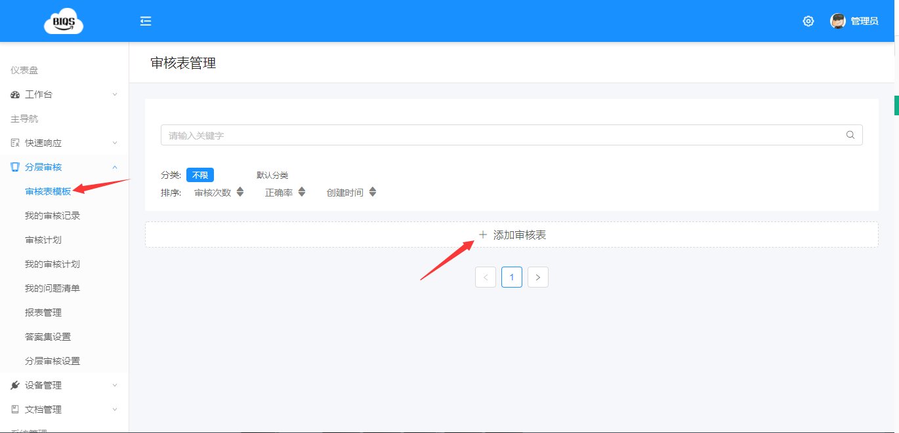

Create New Layered Process Audit Form
- Fill in the audit form title for easy identification
- Select the category of the audit form for easy management
- Upload images for visual identification
- Enter description information
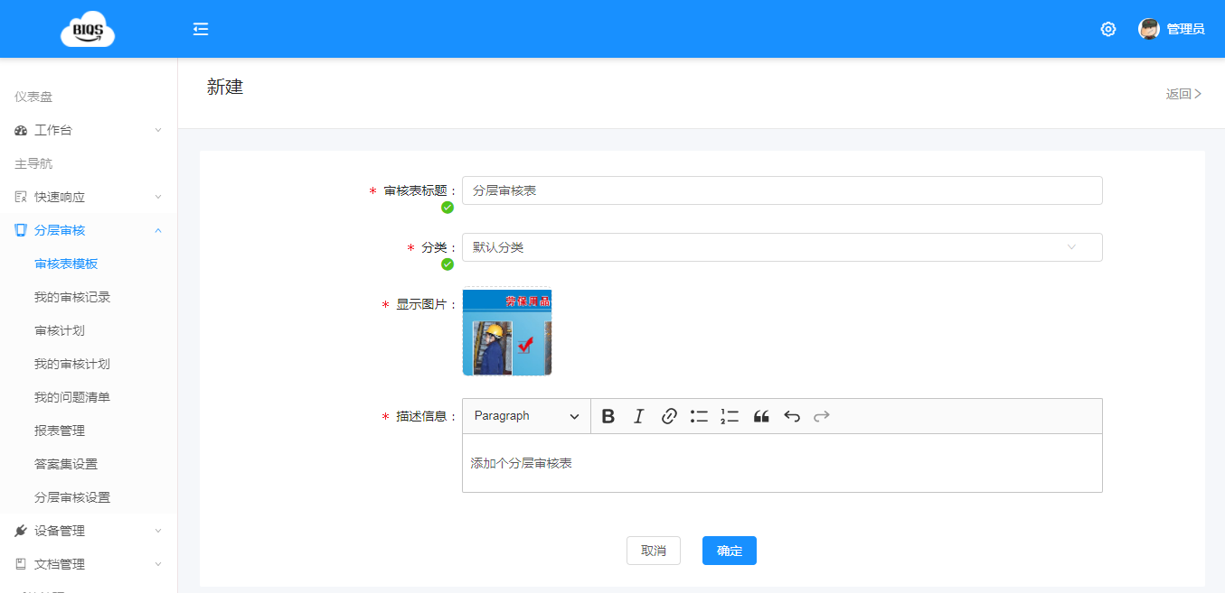

After adding, it will automatically jump to the interface for adding audit inspection points

Add Audit Point List
You can add issues one by one Support batch adding of multiple issues
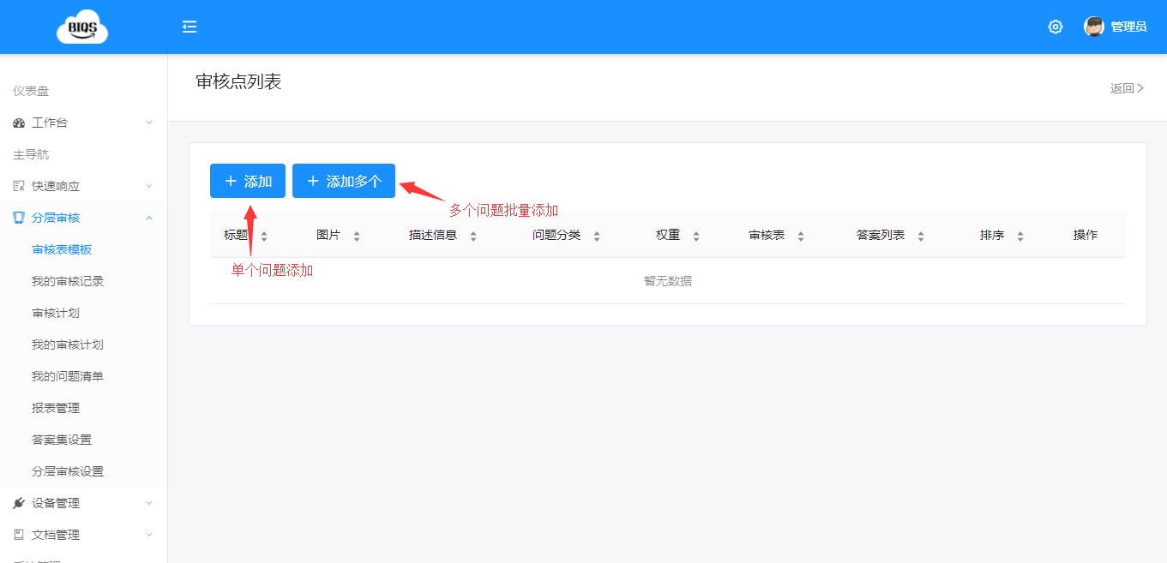

Add Multiple Audit Points at Once
- Batch copy and paste multiple issue points to be audited
- Select the answer set
- Select the issue category
- Save and complete
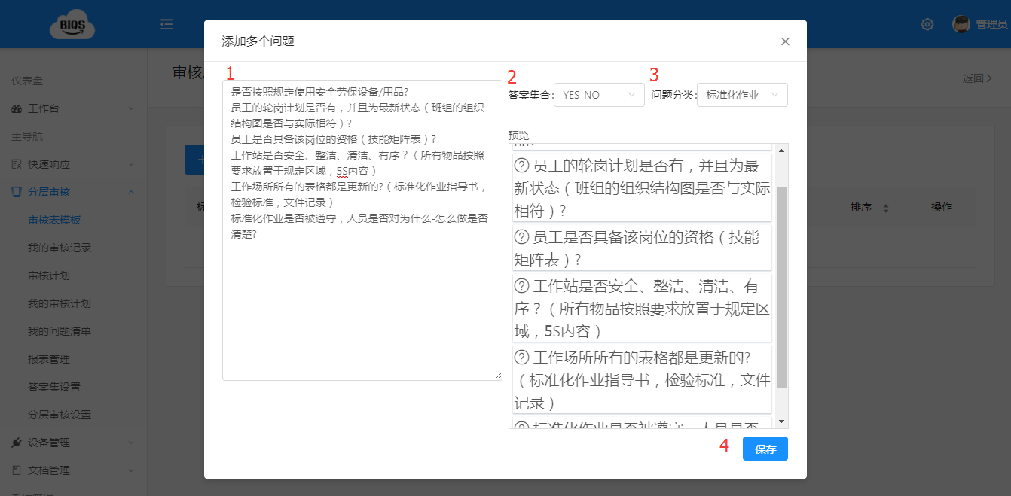

Congratulations, you have completed adding the audit form template!

Audit plan

Add the corresponding audit plan for the audit form template
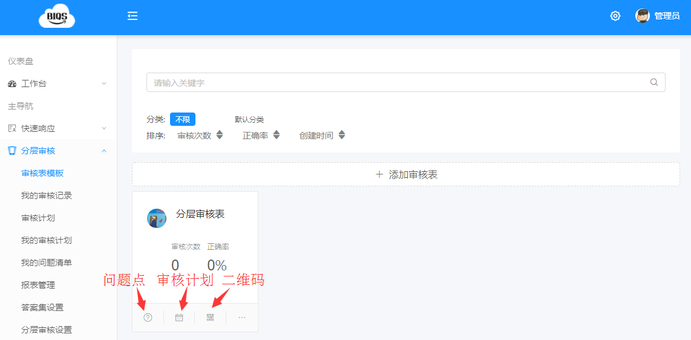

Click Add Audit Plan

Step 1: Set Auditor
- Fill in the plan name for easy identification
- Select the plan for the corresponding audit form
- Select the audit position
- Select the auditor
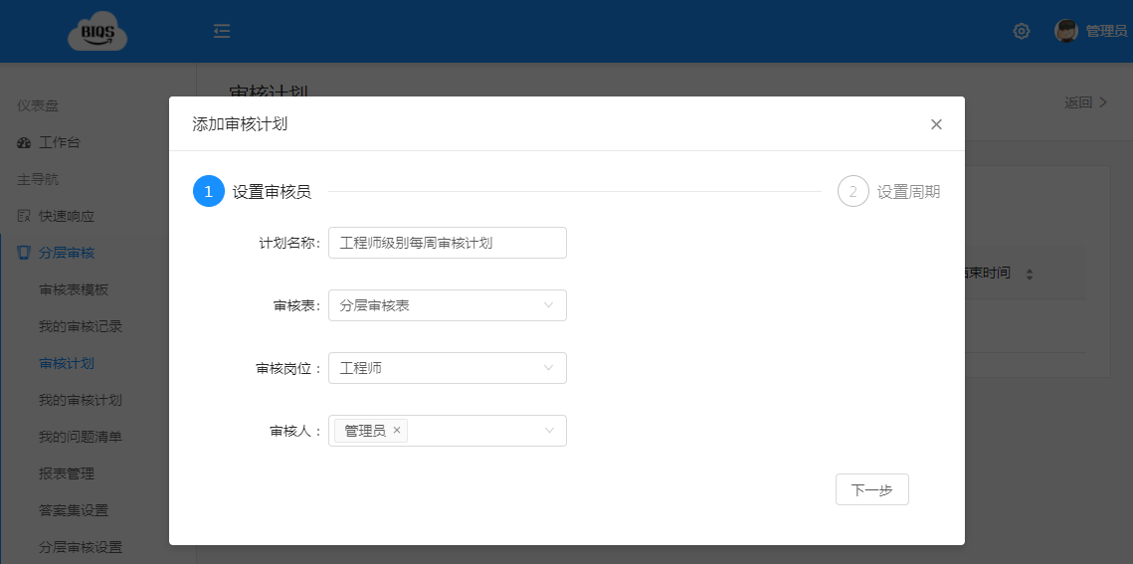

Step 2: Set Cycle
- Select cycle: supports monthly or weekly
- Select which day in the cycle to repeat: directly select the corresponding date
- Set flexible days: days before and after the selected date are not considered overdue, audits can still be conducted
- Time range: the audit plan is valid within the specified time range
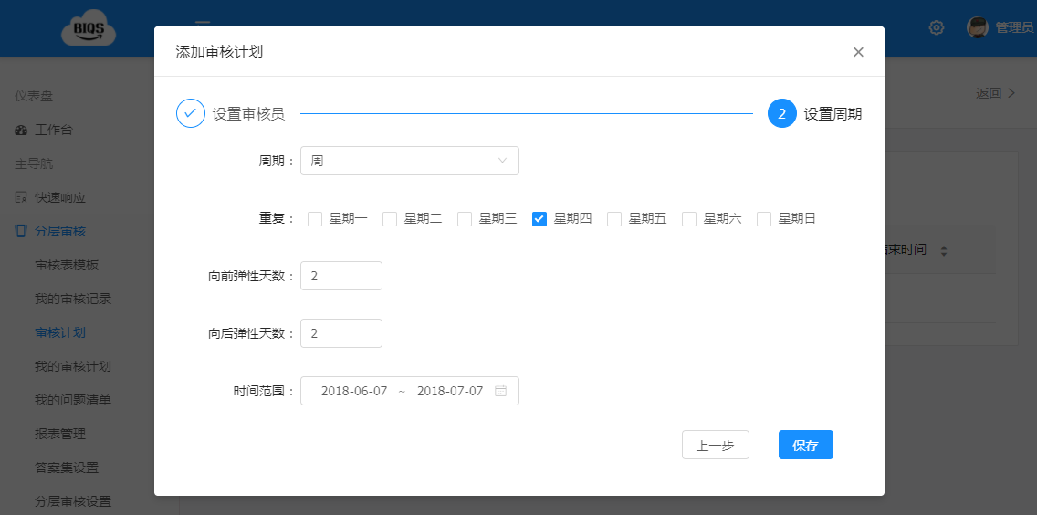

Level 2 Audit Plan Addition
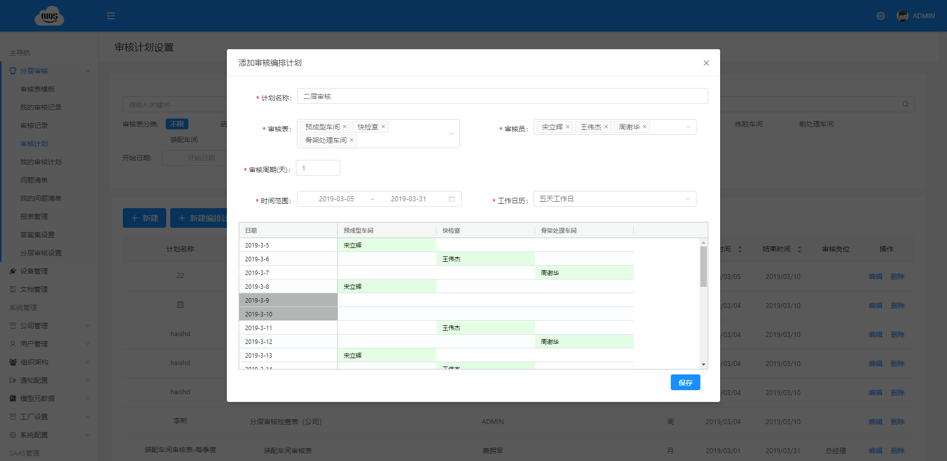

Level 3 and 4 Audit Plan Addition
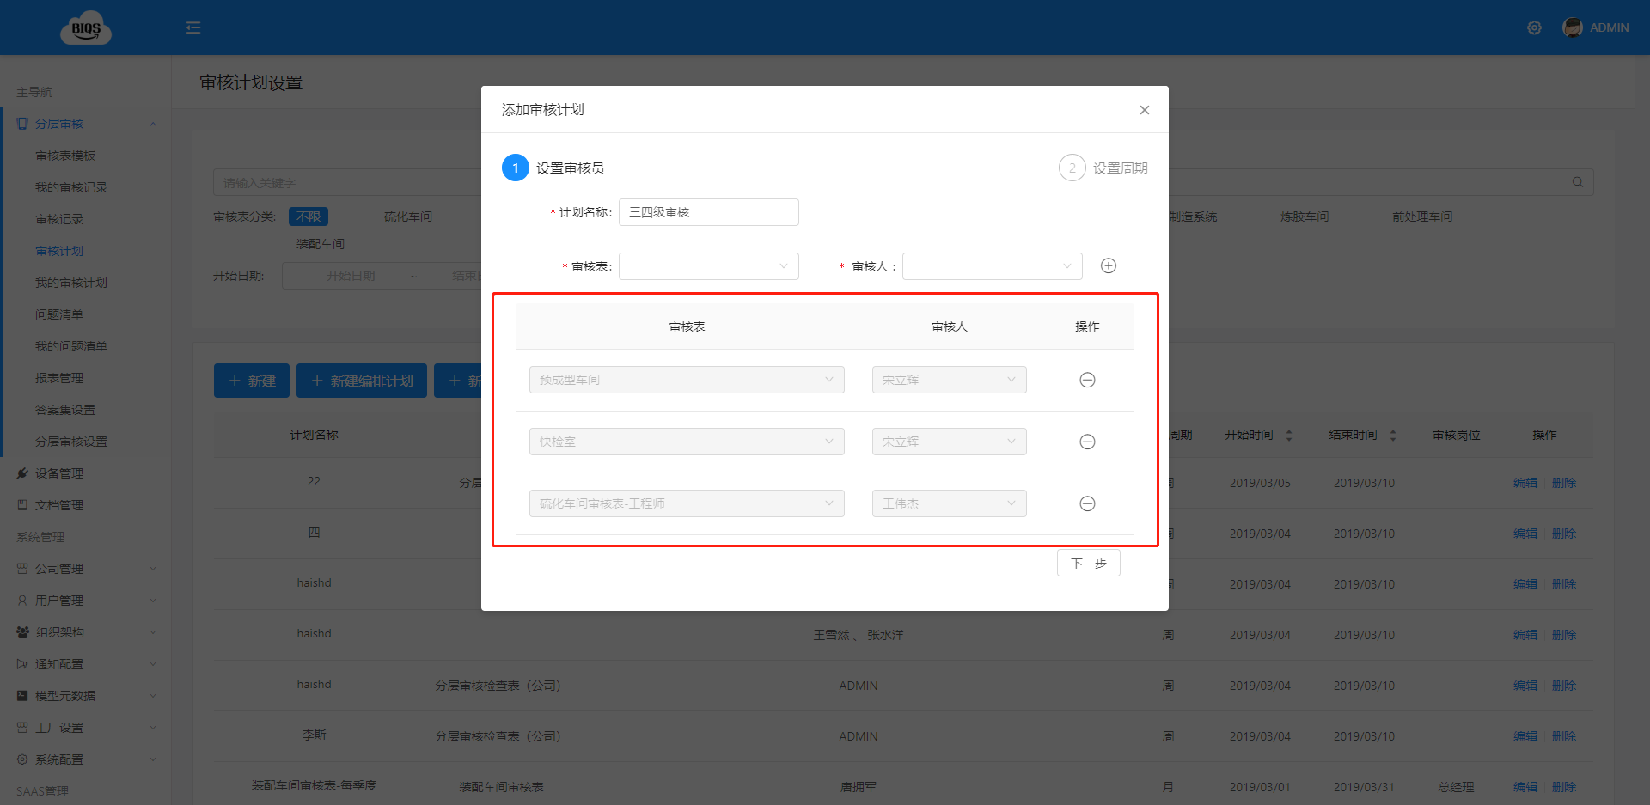

The corresponding audit plan will be generated on the user’s mobile device
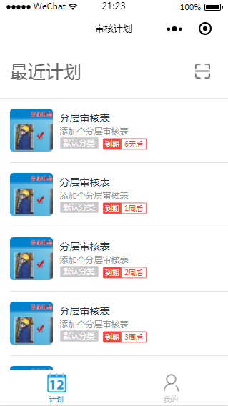

Congratulations, you have completed adding the audit plan!

Audit Record

Web-based Audit Record Query
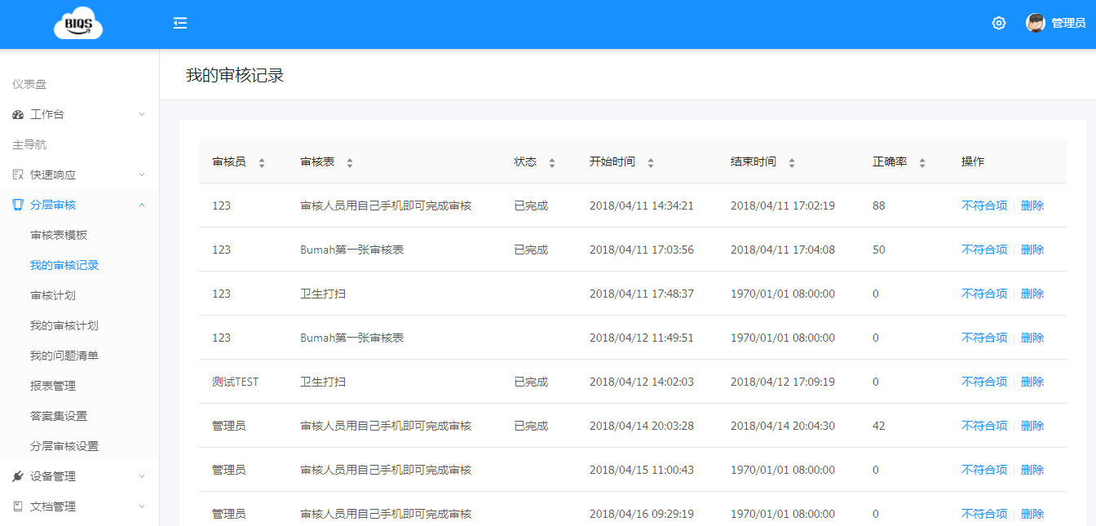

Issue List

Computer-based Issue List

Divided into Issues I Found and Issues I Handle

Issues I Found
Issue description Urgency level Assigned responsible person Enter due date Confirm if the improvement evidence submitted by the responsible person is valid Close the issue
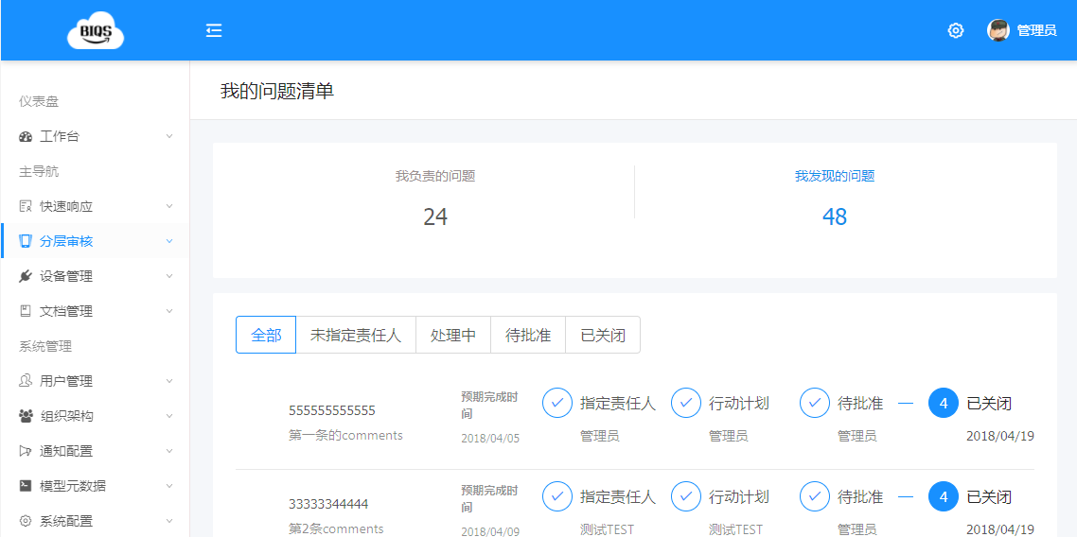

Issues I Handle
Submit action plan Let the auditor close the issue
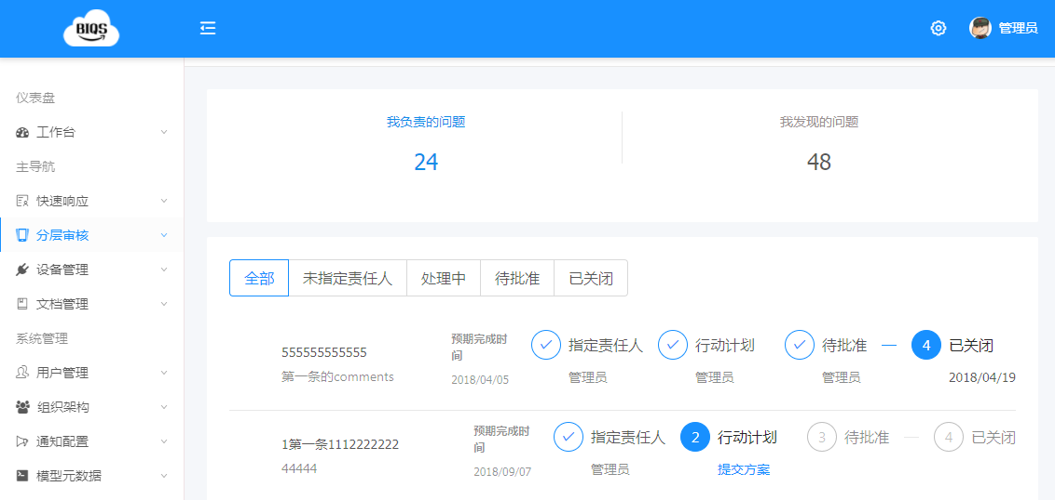

TIPS: Every change in issue status will send email notification to relevant personnel (assigned responsible person, submit action plan, issue closed, etc.)

Congratulations, you have learned issue point tracking and management!

Report

Report Management

Currently several commonly used reports have been developed, and customized reports can also be developed according to customer needs
Audit Completion Rate Issue Closure Rate Auditing Department Report Responsible Department Report Issue Classification

Audit Completion Rate Statistics
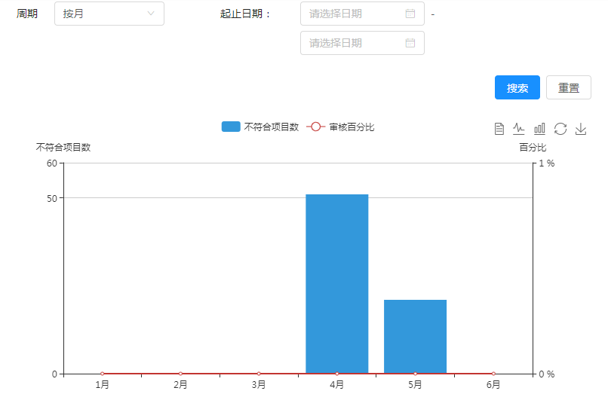

Issue Closure Rate Statistics
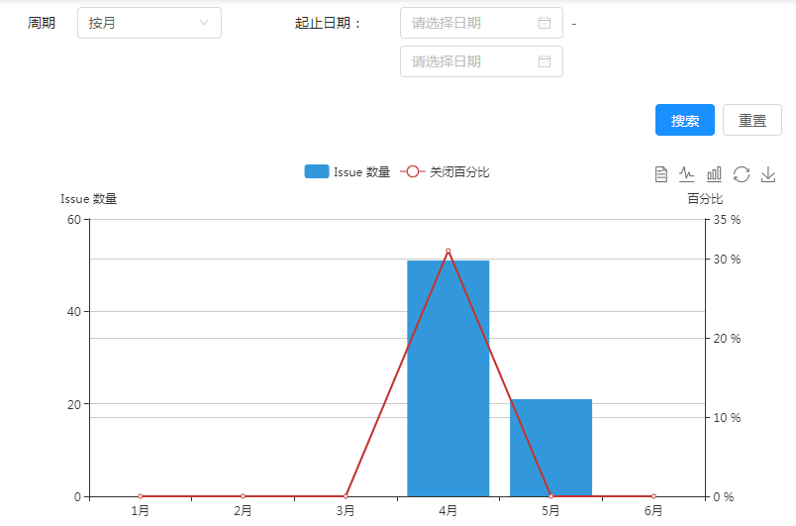

Responsible Department Statistics
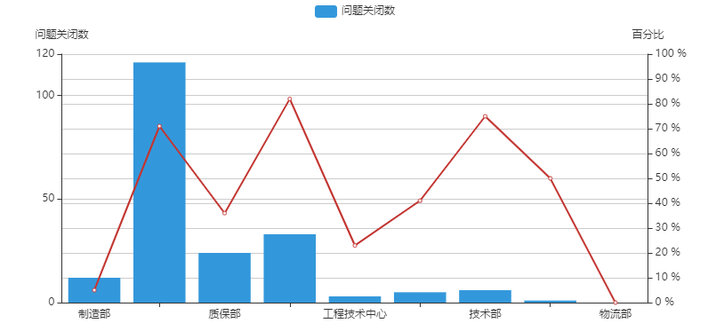

Auditing Department Statistics
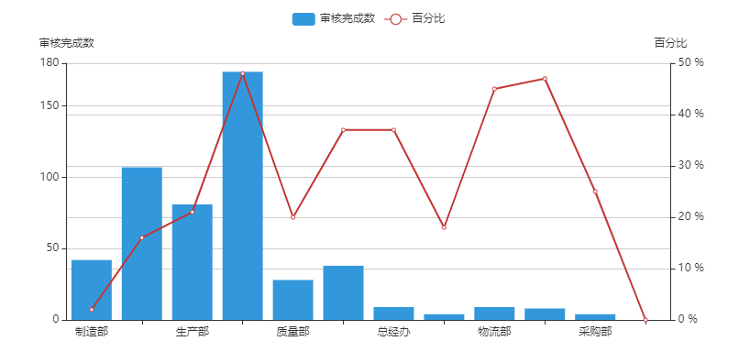

Issue Classification Statistics
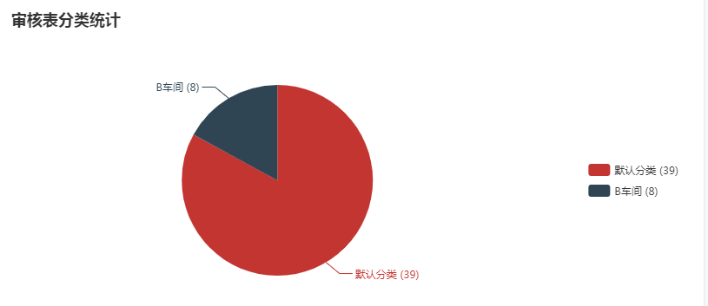
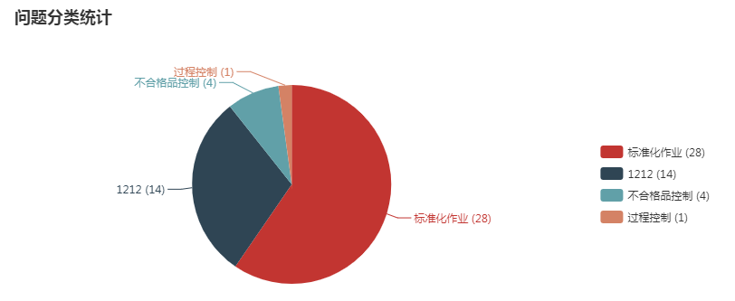
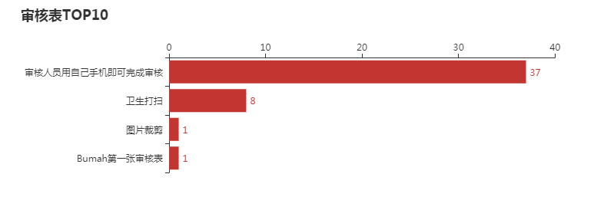

Settings

Layered Process Audit Settings

Other setting options for Layered Process Audit software
Audit Form Classification Issue Point Classification Answer Set Configuration Must be on-site to scan and audit

Audit Form Classification
The classification of audit forms facilitates management. Audit forms can be classified by workshop or by product, arbitrarily set according to company needs.

Issue Point Classification
When adding audit form issue points, classify the issue points, such as: nonconforming product management, standardized operations, quality focus areas, etc. This helps understand which aspects of the enterprise are weak through final data statistics.

Answer Set Configuration
Can be arbitrarily added, such as Yes/No, Conforming/Non-conforming, etc.

On-site Audit
Can set that auditors must be on-site to scan and audit. This prevents auditors from having mobile audit tools but completing audit tasks directly in the office without going to the site.

For Users

In this chapter, we will learn the basic operations on the mobile device
Audit Plan
Audit Records
Issue List
Expired Plan

Audit Plan

Audit Plan on Mobile Device

The mobile device displays all plans within the last 1 month

Based on the floating range of audit dates set in the backend, it will prompt that the current date cannot start auditing
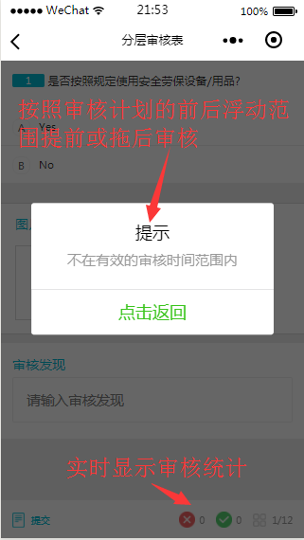

The mobile device prompts that the time has not arrived yet, and auditing cannot be conducted temporarily to prevent completing all audit plans at once
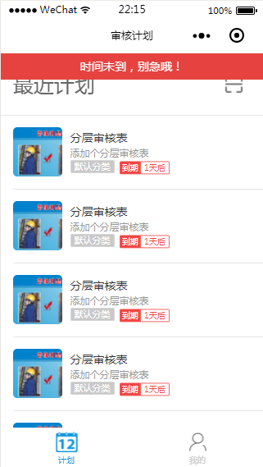

Audit Record

Mobile-based Audit Record Query

Go to Personal Center on the mobile device -> Audit Records
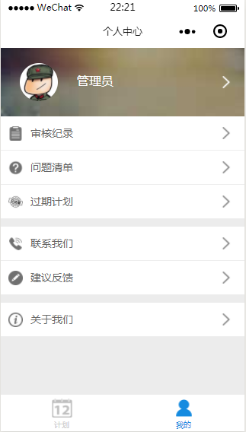

Audit Record Page Features
Query nonconforming items Delete audit records Statistics on audit quantity Display audit time

Incomplete audits show red “Temporarily Saved,” completed audits show green with compliance rate percentage
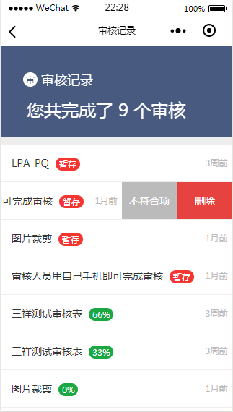

Nonconforming Items for a Certain Audit Form
Issue status Issue level Assigned responsible person


Assign Responsible Person
Issue description Urgency level Responsible person Due date 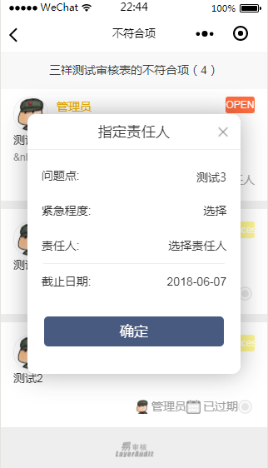

Congratulations, you have learned how to assign issue points to responsible persons after auditing

Issue List

Mobile-based Issue List

Divided into Issues I Found and Issues I Handle

Issues I Found
Issue description Urgency level Assigned responsible person Enter due date Confirm if the improvement evidence submitted by the responsible person is valid Close the issue
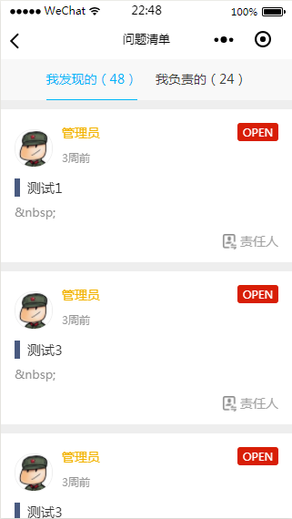

Assign Responsible Person
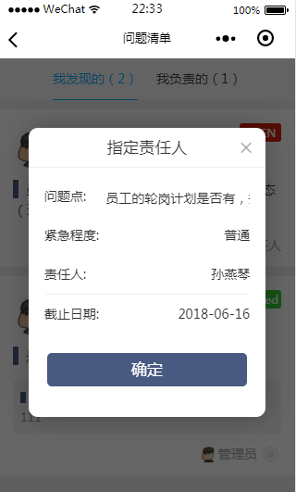

Issues I Handle
Submit action plan Let the auditor close the issue
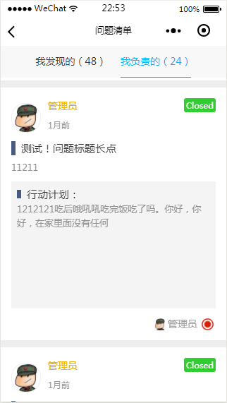

Action Plan Approval
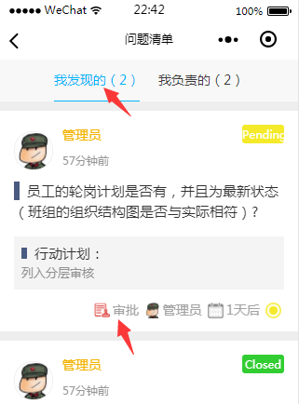

Submit Action Plan
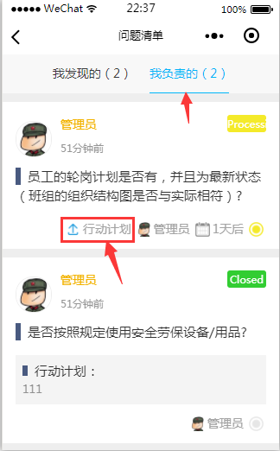
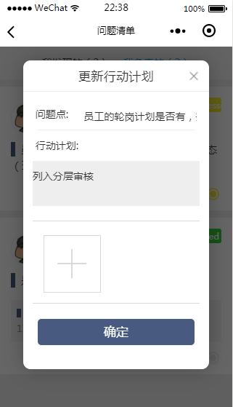

TIPS: Every change in issue status will send email notification to relevant personnel (assigned responsible person, submit action plan, issue closed, etc.)

Congratulations, you have learned issue point tracking and management!

Expired Plans

Mobile-based Query for Expired Plans
The mobile device will list expired plans and their quantities


Enter Expired Reason
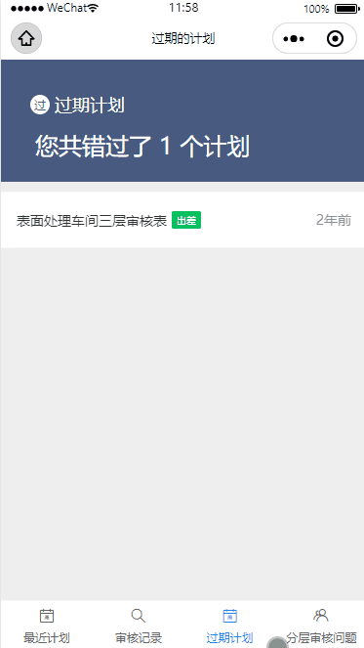

Mobile-based Audit

Mobile-based Audit

Mobile Audit Interface
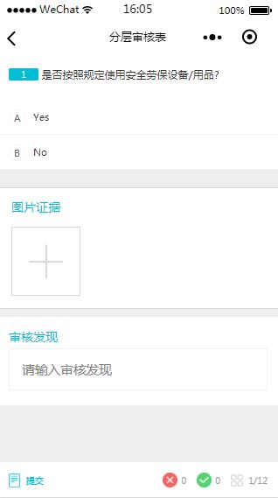

Anroid Application

In this chapter, we will learn the basic operations on the mobile device
Audit Plan
Android Device Audit
Audit Records
Issue List
Expired Plan

Audit Record

Android-based Audit Record Query

Go to Personal Center on the Android device -> Audit Records
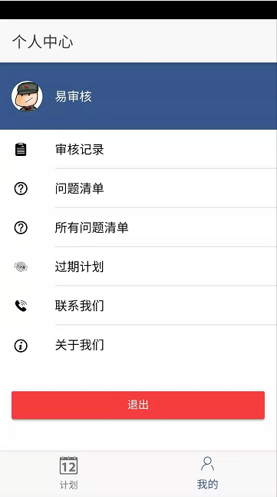

Audit Record Page Features
Query nonconforming items Delete audit records Statistics on audit quantity Display audit time

Incomplete audits show red “Temporarily Saved,” completed audits show green with compliance rate percentage
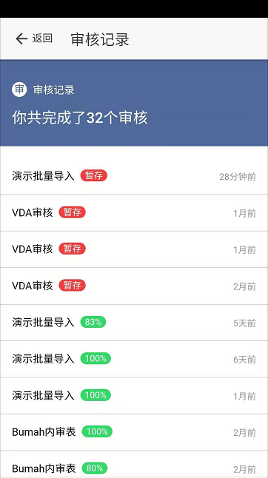

Congratulations, you have learned how to query audit records

Expired Plans

Android-based Query for Expired Plans
Android will list expired plans and their quantities
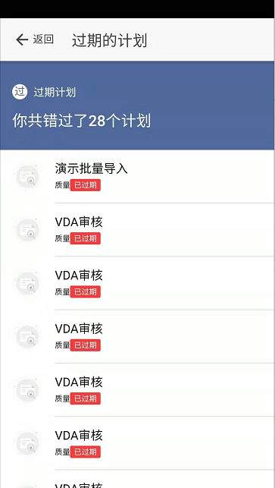

Issue List

Issue List for a Certain Audit Form
Issue status Issue level Assigned responsible person
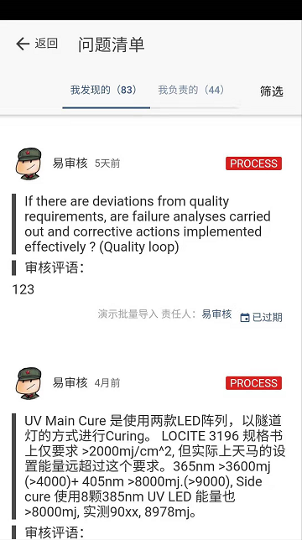

Assign Responsible Person

Click the assign responsible person interface, the system will pop up the assign responsible person interface. Enter the following to assign the issue responsible person
Issue description Urgency level Responsible person Due date 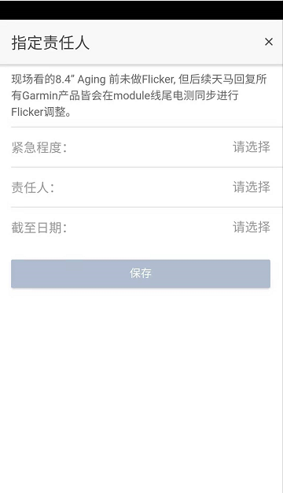

Close Issue

In [Issues I Handle], click Action Plan, and the following interface will pop up to enter the action plan to close the issue.
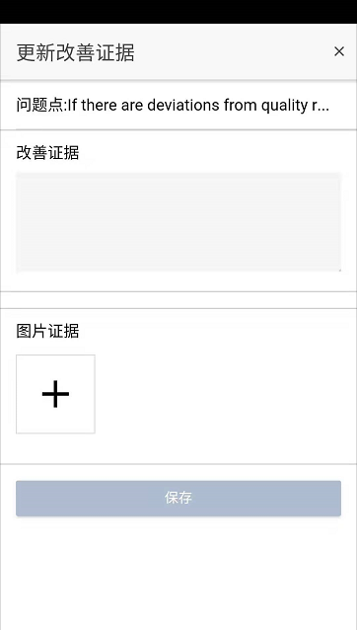

Audit Plan

Audit Plan on Android

Android displays all plans within the last 1 month
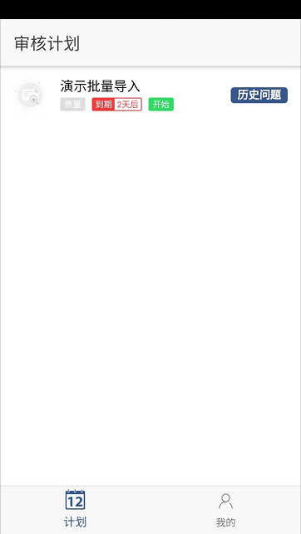

According to the audit team settings by the backend administrator, the list of auditors present will pop up before the audit for the user to select for attendance
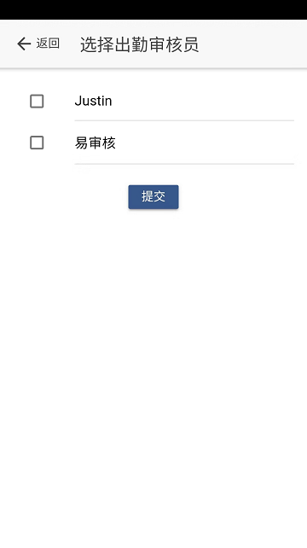

After selection is complete, if within the audit time range, start auditing

Android Audit

Android Audit

Android Audit Interface

If a nonconforming item is selected, a window for inputting audit findings will pop up, requiring input of findings. The small triangle in the upper right corner can be clicked to select pre-set common input phrases
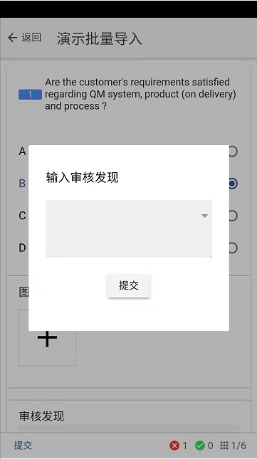

Swipe right to enter the next issue point

After clicking the bottom right corner, the overall status of the issue audit will pop up. Red means there are nonconforming items after auditing, green means conforming items after auditing, gray means not yet audited
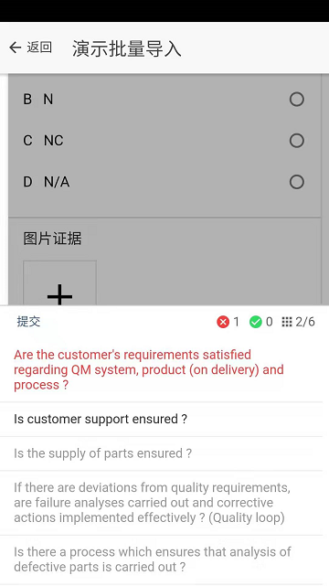

Deployment Options

Supports Multiple Deployment Options
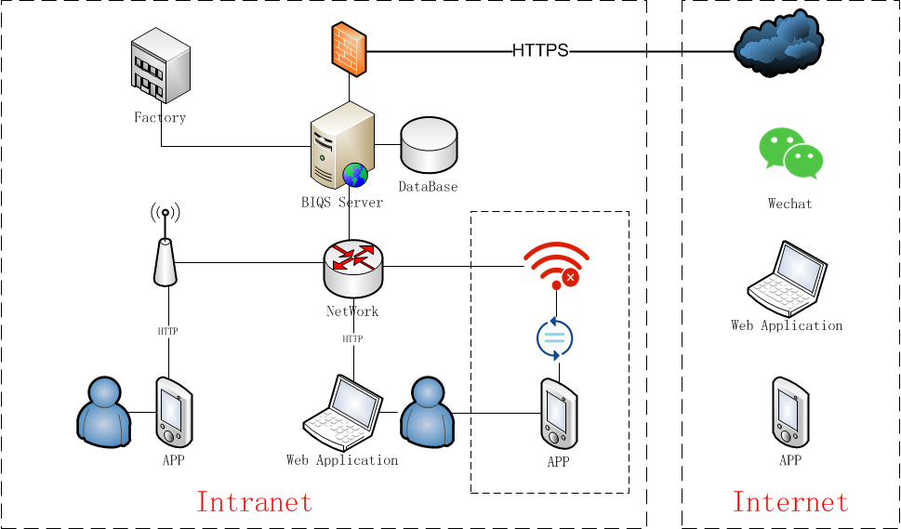

1. Enterprise Private Deployment

Preparation Work
- WeChat Mini Program Free Registration Process
- Domain name, determine the deployment domain name and resolve it to the corresponding deployment server public IP address (SSL certificate application required)
- SSL Certificate Free Application Address
- System Requirements
  - (Recommended) CentOS 7.x version, open ports 22, 80, 443 to external network
  - (Alternative) Or Windows Server 2012 and above, open ports 80, 443, 3389 to external network

2. If the enterprise has no network, synchronize audit results

3. Cloud Deployment (WeChat Mini Program Supported)

